Chapter 1

Exercise Solutions

Ex 1.1
(a) Number of atoms per unit cell
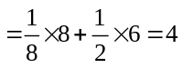
(b) Volume Density 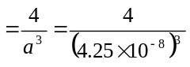
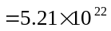cm
_______________________________________

Ex 1.2
Intercepts of plane; p=1, q=2, s=2
Inverse; 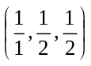
Multiply by lowest common denominator,
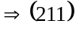 plane
_______________________________________

Ex 1.3
- Number of atoms per (100) plane
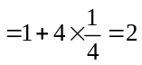
Surface Density 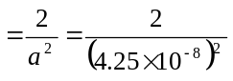
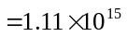cm
- Number of atoms per (110) plane
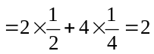
Surface Density
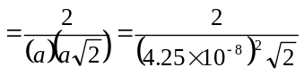
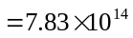cm
_______________________________________
Test Your Understanding Solutions

TYU 1.1
Number of atoms per unit cell 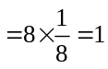
Volume Density 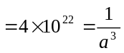
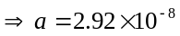cm 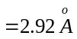
Radius 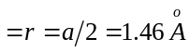
_______________________________________
TYU 1.2
- Number of atoms per (100) lattice plane
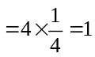
Surface Density 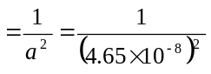
=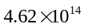cm
- Number of atoms per (110) lattice plane
Surface Density
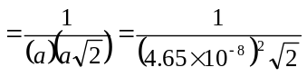
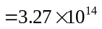cm
- Number of atoms per (111) lattice plane
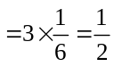
Lattice plane area 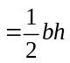
where 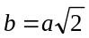
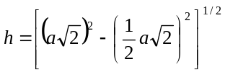
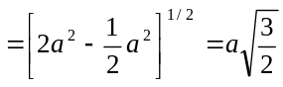
Then lattice plane area
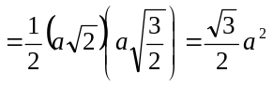
Surface Density
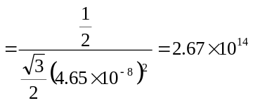cm
_______________________________________

TYU 1.3
- For (100) planes, distance 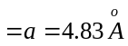
- For (110) planes, distance
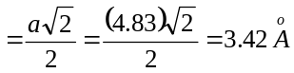
_______________________________________

TYU 1.4
- 8 corner atoms
- 6 face-centered atoms
- 4 atoms totally enclosed
_______________________________________

TYU 1.5
Number of atoms in the unit cell
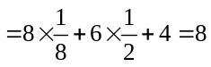
Volume Density 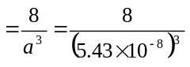
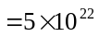cm
_______________________________________

